6. Vendor Maintenance

Table of Contents
Vendor Maintenance 2
Direct Pay Info 6
History 7
Accounts 9
Del… Move… 10

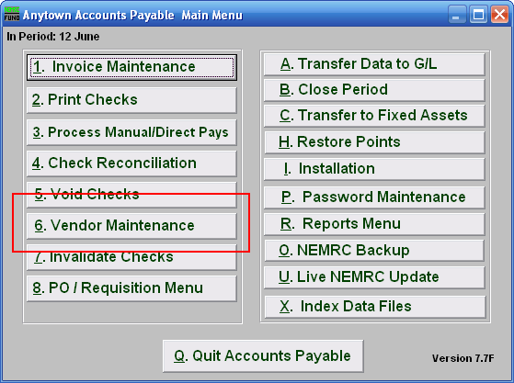
Click on “6. Vendor Maintenance” from the Main Menu and the following window will appear:

Vendor Maintenance

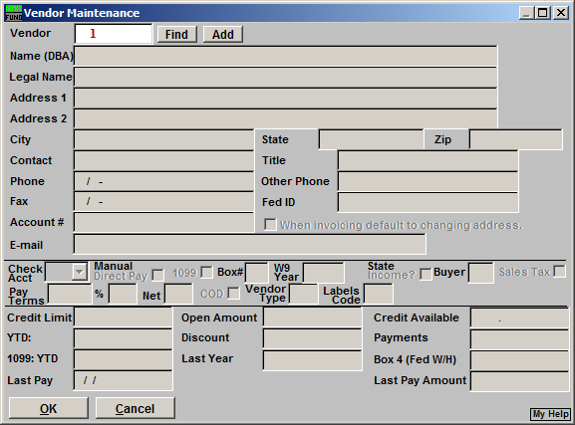
- Vendor: Enter an existing Vendor number and click “Find,” or enter a new Vendor number and click “Add.” For more information on Vendor Lookups, refer to AP GENERAL VENDOR LOOKUPS.

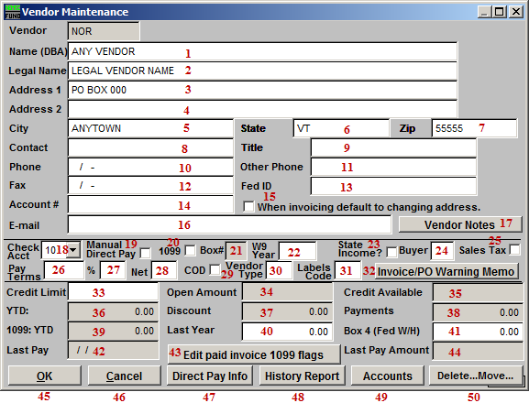
- Name (DBA): Enter the company name.

- Legal Name: Enter the company’s legal name.

- Address 1: Enter the company mailing address.

- Address 2: Enter the company’s secondary address (if applicable).

- City: Enter the city or town for company mailing address.

- State: Enter the state for the company mailing address.

- Zip: Enter the zip code for the company mailing address.

- Contact: Enter a personal contact for the company.

- Title: Enter the title for the personal contact.

- Phone: Enter the phone number for the personal contact.

- Other Phone: Enter another phone number for a contact.

- Fed ID: The Federal ID number may be a SSN for some sub contractors or small businesses that do not have a business Federal ID number. No Vendor should be paid if they have not submitted a W9 to your office.

- Fax: Enter the fax number for the personal contact of the company.

- Account #: Enter your customer number that this company uses to identify your organization.

- When invoicing default to changing address: The option guides you to automatically update the payment mailing address during the invoicing process.

- E-mail: Enter an E-mail for the personal contact.

- Vendor Notes: Clicking this will open a window where you may keep notes. The vendor listing will offer this information when printed in detail. Clicking OK will save any changes and close the notes window, Clicking Cancel will close the notes window without saving, and clicking Print will print whatever is selected (if nothing is selected, it will print all notes). Refer to GENERAL PRINTING for more information.

- Check Acct: Enter the checking account that will be used to pay this Vendor (this will be the default and can be changed on the Invoice Maintenance screen). Checking account codes are defined in Installation Maintenance.

- Manual/Direct Pay: Click to choose this option. If this Vendor is commonly paid via manual or direct pay then check this box so that invoice will default that type of payment during invoicing.

- 1099: Click to choose this option. When this is defaulted then all invoices will default to accumulate purchased amounts for a 1099 reporting at the end of the calendar year. The option can be turned off on individual invoices when needed.

- Box#: Enter the box on the 1099 that this amount will print in for the 1099, for example, Box “7” would be for non employee compensation.

- W9 Year: Enter the year to W9 was signed and returned to your organization. The system can test on this field during invoice processing when the option is enabled in Installation.

- State income: Click to select this Vendor to report State Income.

- Buyer: User defined buyer code can be used for some report selections.

- Sales Tax: Click to select this Vendor to report sales tax.

- %: Enter the default percentage for discounts.

- Days: Enter the default number of days for discount to apply.

- Net Days: Enter the number of days for which the net invoice is due.

- COD: Click this to mark as cash on delivery Vendor.

- Vendor Type: User defined. This may be used to print certain Vendors. An example is “S” for supplies; which would allow you to print all of the Vendors that you purchased supplies from during the year. This should be done in a consistent manner.

- Labels Code: User defined.

- Invoice/PO Warning Memo: Clicking this will open a window where you may keep Memos. The information entered here will appear when entering invoices or purchase orders for this vendor. The vendor listing will offer this information when printed in detail. Clicking OK will save any changes and close the memo window, Clicking Cancel will close the memo window without saving, and clicking Print will print whatever is selected (if nothing is selected, it will print all memos). Refer to GENERAL PRINTING for more information.

- Credit Limit: Enter the amount of credit limit this Vendor will provide.

- Open Amount: This displays the present amount of unpaid invoices that are in the system.

- Available Credit: This displays the amount of open credit remaining on this Vendor.

- YTD: This displays the year to date purchases made to this Vendor.

- Discount: This displays the year to date discounts taken with this Vendor.

- Payments: This displays fiscal to date payments made to this Vendor.

- 1099 YTD: This displays the year to date 1099 reportable payments made to this Vendor.

- Last Year: This displays 1099 values that will print. After you close the period that includes the calendar year this field will contain the information that will print on the 1099. You may edit this field after closing the year if you find you did not accumulate payments for 1099’s or if you did and this Vendor should not get a 1099.

- Box 4 (Fed W/H): Enter into this field the amounts withheld for federal taxes against this Vendor. This is used when a W-9 is not on file for the Vendor and taxes must be withheld.

- Last Pay: This display’s the last date this Vendor was paid.

- Edit Paid Invoice 1099 flags: This option with list all invoices that have been paid and allow updating them to be reflected in the 1099 reportable amounts for last year or this year.

- Last Pay Amount: This display’s the last amount paid to this Vendor.

- Okay: Click this button to save the changes made to this Vendor.

- Cancel: Click this button to not save the changes made to this Vendor.

- Direct Pay Info: If the Vendor is set up as direct pay you will need to fill in the screen (see “Direct Pay Info” below). Once set up you will use the Manual Direct pay option to select the invoice that was paid through this method.

- History: Clicking on the History report button will allow you to gather information for the selected Vendor for a selected due date range and check date range (see “History” bleow).

- Accounts: Click this button to enter default accounts and percentages to distribute invoices (see “Accounts” below). This is not required.

- Del…Move…: Click this button when you wish to combine this Vendor history into another Vendor code or to remove the Vendor from the system. A Vendor should not be removed if it has been used with in the last five years.

Direct Pay Info
If the Vendor is set up as direct pay you will need to fill in this screen. Once set up you will use the Manual Direct pay option to select the invoice that was paid through this method.

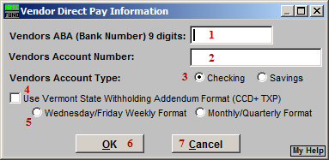
- Vendors ABA (Bank Number) 9 digits: Enter the ABA number for this Vendor’s financial institute for electronic payment processing.

- Vendors Account Number: Enter the Account Number for payments at the financial institute above.

- Vendors Account Type: Select either checking or savings for the Vendors type of account receiving payments.

- Use Vermont State Withholding Addendum Format: This is a specific format used in the addenda record for VT State Withholding. Use this option when this Vendor is a Tax Withholding vendor for the State of VT and you are required to send the money to them in this manner.

- Wednesday/Friday Weekly Format OR Monthly/Quarterly Format: This will be specified by the State of VT.

- OK: Click this button to save changes.

- Cancel: Click this button to not save changes.

History
Clicking on the History report button will allow you to gather information for the selected Vendor for a selected due date range and check date range.

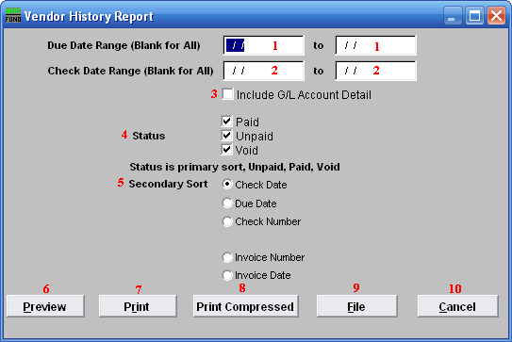
- Due Date Range (Blank for All): You may enter a due date range of invoices for reporting.

- Check Date Range (Blank for All): You may enter a check date range for reporting.

- Include G/L Account Detail: Click this box to report the reference accounts used on this report.

- Status: Click on each status condition for which you would like to report.

- Secondary Sort: Select one method of secondary sort to report the information collected.

- Preview: Click this button to preview this report. Refer to GENERAL PREVIEW for more information.

- Print: Click this button to print this report. Refer to GENERAL PRINTING for more information.

- Print Compressed: Click this button to print the report. This is different from the “Print” option in that it will use less paper for the same report.

- File: Click this button to save this report on this computer. Refer to GENERAL FILE for more information.

- Cancel: Click “Cancel” to cancel and return to the previous screen.

Accounts
Click the Accounts button to choose General Ledger accounts to be set up as default accounts for this Vendor. This option can also be set up for automatic distribution of an invoice amount to be spread over several accounts by percentage. An example would be a phone Vendor that you would set up for different departments, split according to percentages already decided. The office general ledger account would be set up for 60 percent of the total bill, the town garage with 20 percent of the total bill and the sewer department with 20 percent of the total bill. The percentages must add up to 100 percent.

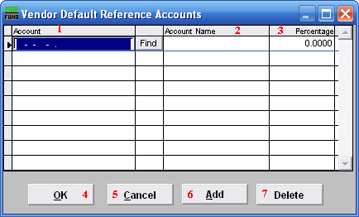
- Account: Enter a General Ledger reference account to default on this Vendors invoices.

- Account Name: This column will display the description of the account as defined in the General Ledger.

- Percentage: Enter a default percentage of the invoice amount to charge against this account.

- OK: Click this button to save the changes.

- Cancel: Click this button to not save the changes.

- Add: Click this button to add additional reference accounts.

- Delete: Select an account from the table and click this button to remove it from the table.

Del… Move…

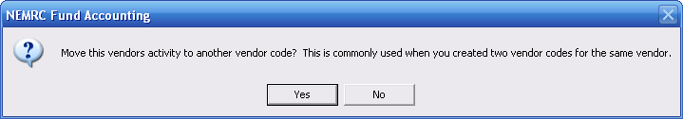
Choose “Yes” to merge this Vendor with another existing Vendor. Choose “No” if you wish to simply delete this Vendor. If you chose “Yes” the following window will appear:

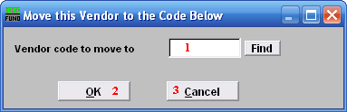
- Vendor code to move to: Enter a valid Vendor code or click FIND to select a Vendor for combining data with.

- OK: Click this button to save changes.

- Cancel: Click this button to not save changes.

If you chose “No,” or after you choose “OK,” the following window will appear:

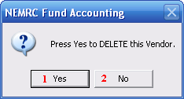
- Yes: Click this button to delete the Vendor from the system.

- No: Click this button to not delete the Vendor from the system.

